Tutorial Sheet-1
Answers
Part-A
- State any three condition
- 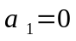
- 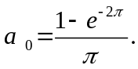
- 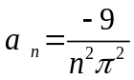
- 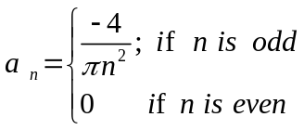
Part - B
- f(x)=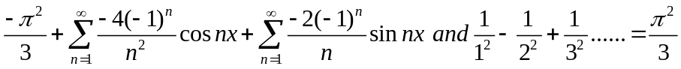
- f(x)=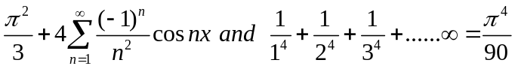
- f(x)=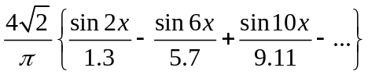
- f(x)=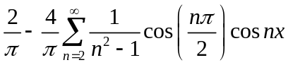
- f(x)=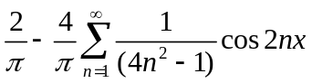

Tutorial Sheet-2
Answers
Part-A
- f(x)=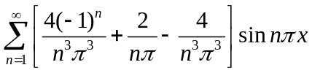
- Take 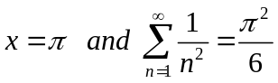
- 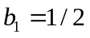
- Take 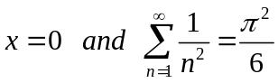
- f(x)=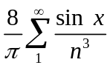
Part- B
- f(x)=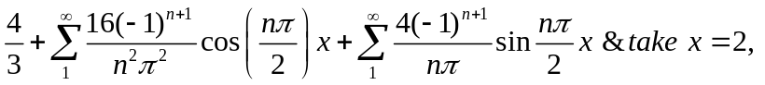
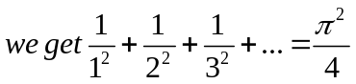
- f(x)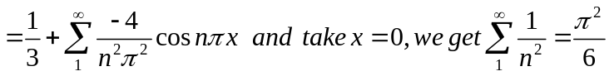
- f(x)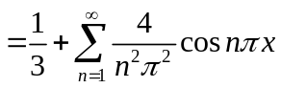
- f(x)
- cosine series: f(x)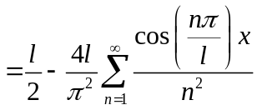
sine series f(x)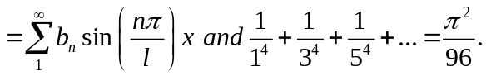

Tutorial Sheet-3
Answers
Part -A
- R.M.S =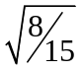
- R.M.S=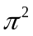
- R.M.S: The root mean square value of a function
Y=f(x) over a given interval (a,b) is defined as 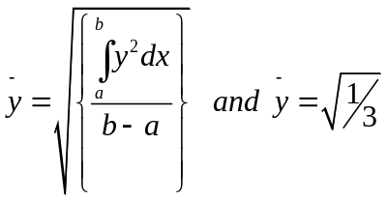
- f(x)=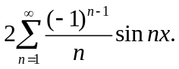
- f(x)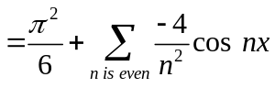
Part-B

- f(x)
- f(x)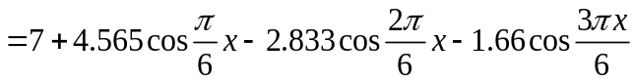
- f(x)
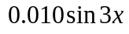
- f(x)=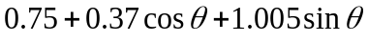
- f(x)

